**<TITLE OF SMP RESEARCH PAPER>**

<Surname Given Name of student1 >1, <Surname Given Name of student2 >1 and <Surname Given Name of student3>1

Mentor(s): <Surname Given Name of mentor1 >2 and <Surname Given Name of mentort2 >2

1 <Institution>, <Address>

2 <Faculty/Department>, <Institution>, <Address>

**ABSTRACT**

<This should be a brief and informative summary of the main findings of the paper. It should not exceed 200 words.>

**INTRODUCTION**

<This should be clear and include the purpose of the work. >

**MATERIALS AND METHODS**

<Experimental details should be concise but sufficient to allow a qualified operator to repeat the work. Refer to previously published procedures employed by citing the paper. Do not include extensive details unless they present substantially new modifications. >

**RESULTS**

<This may be presented in text, tables, figures or photographs. Figures, photographs and tables should be placed in the appropriate place where they are first cited in the text and they must have clear headings (**Table 1**, **Table 2**, **Figure 1**, **Figure 2** etc.). Only originals must be submitted and unless they are biological drawings, they should not be hand drawn. Students are advised to use computer software programmes for plotting graphs. Figures, photographs and graphs will not be printed in colours, unless really necessary. >

For example, the caption of any table of results should be presented as shown.

**Table 1: The measured zone of inhibition of *E. coli* with natural herbs and antibiotic**

|  |  |  |  |  |  |  |  |
| --- | --- | --- | --- | --- | --- | --- | --- |
|  | **Zone of inhibition / mm** | | | | | **Change / %** | **Ranking** |
| **Herb/plate** | **1** | **2** | **3** | **4** | **Average** |
| **Antibiotic** | 36 | 29 | 33 | 30 | 32 | **-** | **-** |
| **P + Antibiotic** | 45 | 38 | 29 | 32 | 36 | **16.13** | **1** |
| **Q + Antibiotic** | 25 | 27 | 28 | 32 | 28 | **-9.68** | **3** |
| **R + Antibiotic** | 37 | 32 | 29 | 30 | 32 | **3.23** | **2** |
| **S + Antibiotic** | 21 | 32 | 29 | 30 | 28 | **-9.68** | **3** |

An example of a figure is shown below with caption.

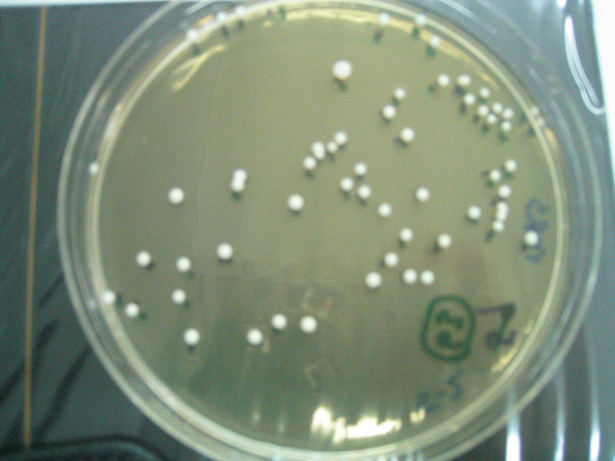

**Figure 2:** A typical dilution plate with well isolated colonies

**DISCUSSION**

<This should be concise and deal with interpretation of results. >

**ACKNOWLEDGEMENTS**

<Remember to acknowledge all those who have helped you in this project.>

**REFERENCES**

<Reference citation should be numbered sequentially as they appear in the text ([1], [2], etc.), followed by those in tables and finally by those in figure legends. Only published papers are numbered and included in the Reference section. All other forms of reference, including unrefereed abstracts, should be cited in the text as personal communications, manuscript submitted or in preparation.>

<The Reference list should contain only author(s)’s name(s), year, title of paper, journal title and the first and last page numbers. Reference to books should include editor(s)’s name(s), publisher and place.>

For example:

[1] Boon, Heather and Michael J .Smith. The Complete Natural Medicine Guide to the 50 Most Common Medicinal Herbs. New York: Cadmos Verlag GmBH, 2004.

[2] M. N. Indu, et. al. (2006). Antimicrobial activity of some of the south-Indian spices against serotypes of *Escherichia coli*, *Salmonella*, *Listeria monocytogenes* and *Aeromonas hydrophila.* Brazilian Journal of Microbiology (2006) 37:153-158

[3] Guinea Lybx (2011) Commonly Prescribed Antibiotics. <http://www.guinealynx.info/antibiotics.html>. Last retrieved, 9 June 2011.